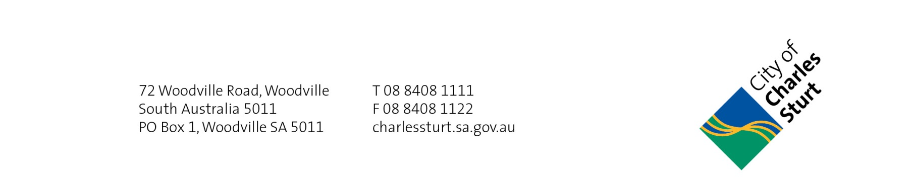
23 April 2019

To the Resident/ Occupier

Dear Resident

Dry Areas Consultation – Midcourse And Shoreline Reserves

The City of Charles Sturt is currently seeking feedback to decide whether to apply to the Office of the Liquor Licensing and Gambling Commissioner for the creation of a new Dry Zone within Midcourse and Shoreline Reserve, West Lakes (see map below).

The Midcourse and Shoreline Reserves are prominent reserves within the West Lakes area that contain a playground for children, public toilets and barbeque cooking facilities for the safe enjoyment of all who utilise the space.

However recently both the City of Charles Sturt and the South Australian Police have received a number of complaints due to anti-social behaviour including public intoxication, offences of assault, property damage and other undesirable offences within the two reserves.

To ensure the community can continue to safely utilise the recreational open spaces within Midcourse and Shoreline Reserves, Council is seeking feedback to decide whether to apply to the Office of the Liquor Licensing and Gambling Commissioner for the creation of a new Dry Zone within the two reserves as highlighted on the map below.

If there is majority support for the proposed Dry Zone the Council is likely to proceed with applying to the Office of the Liquor Licensing and Gambling Commissioner. If the Council application is approved, the consumption of alcohol would be banned on the highlighted areas on the attached map.

Have your say!

To provide your comments on the proposed Dry Zone you can:

- Submit in writing online at www.yoursaycharlessturt.com.au/dry-areas-midcourse-and-shoreline-reserves.

- Post your comments addressed to Dani Scuteri, PO Box 1, Woodville SA 5011

Consultation closes Friday 21 May 2019

For further information or to discuss this project please feel free to contact me on 8408 1305

Yours sincerely

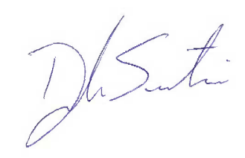

Dani Scuteri
Project Officer - Public Health and Safety

Enclosure

Proposed Dry Zone Areas
