**Map of reserves within St Clair**

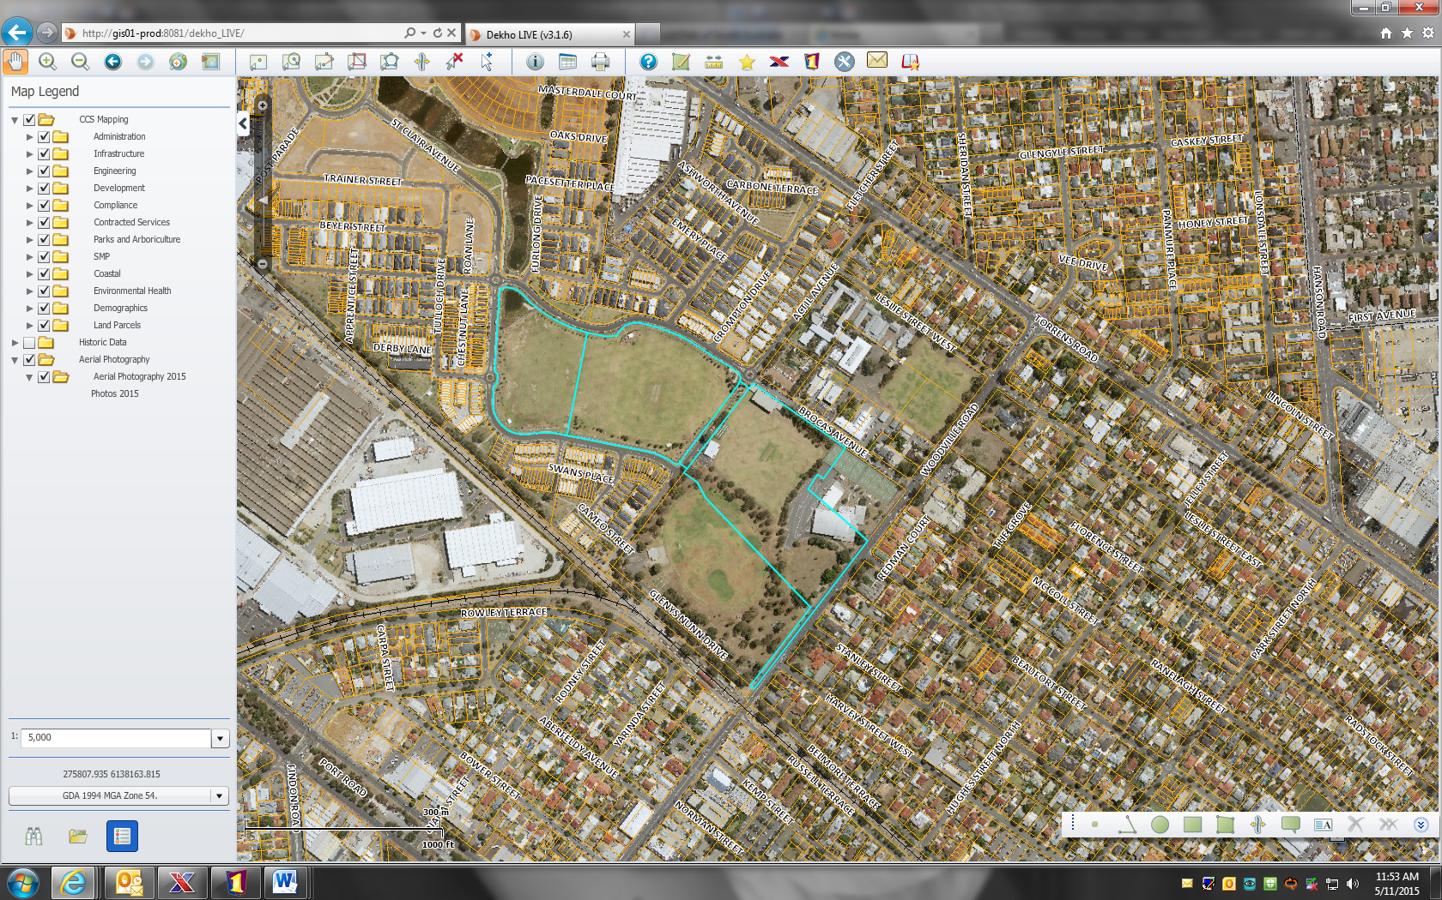

Recreational Reserve

St Clair Oval 2

St Clair Oval 1